Assignment -2

M.surendar

Question 1

What is Relational database ?

A relational database is a database which is based upon the relational model of data.

Question 2

What is Analytical database ?

An analytical database is only desinged to support business descions support system is kown as business intelliengence.

Question 3

Write down the diffirences between Relational Vs Analitical Database?



Question 4

Write down the diffirences between Dataware House Vs Data Mart?

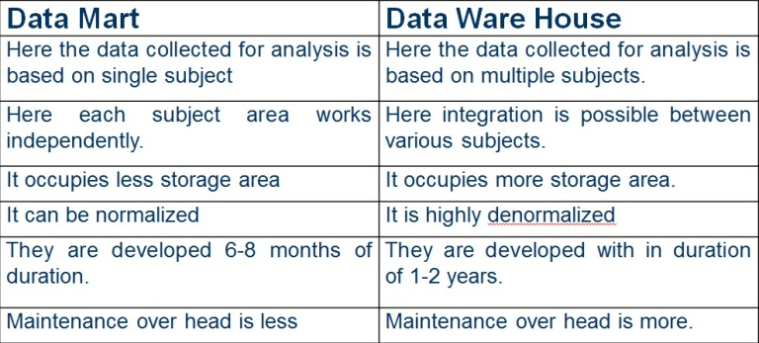

Top of Form

Bottom of Form

Question 5

What is the diffirences between Dependent Vs Indepedent Data Mart ?

           Dependent data mart is retrive a data from data sources .It is depended from data warehouse.

           Independent data mart is direct to recive a data from were we need to collected a data.It is not depend on data warehouse.

Question 6

Please draw & design Data ware House Architecture Diagram ?



Question 7

What is the Staging Area and Why do we need ?

Staging area is temporary place all where all the  source system's data is used to dump which is temporary in nature.  
NEEDS:  
 A staging area is mainly needed in the data warehousing architecture for data cleaning purpose.

Question 8

Specify and explain the Metadata Categories?

The actual meaning of metadata is data about data.

Categories:

There are three types are:

Business Metadata:

Information about business data & policies.

Technical Metadata:

*  It contains about data about tables (EX: Table name,column name,ect..)
* It also provide key details about as primary key and foreing key

Operational Metadata:

* It contains the data for currency and lineage.
* The information about the data history of migrated or transformated.

Question 9

What is the OLAP Cube and why do we need Cube?

An OLAP cube is an multidimensional structure that is optimized.

NEEDS:

* For analysis purpouse.
* It will analysis fast & quick.
* Cube can calculate and accumulated the large no.of. data.

Question 10

What are the OLAP Categories and explain their features ?

OLAP CATEGORIES:

* ROLAP
* MOLAP
* HOLAP

Features:

OLAP **facilitate interactive query and complex analysis for the users.** OLAP allows users to drill down for greater details or roll up for aggregations of metrics along a single business dimension or across multiple dimension. OLAP provides the ability to perform intricate calculations and comparisons.

|  |  |
| --- | --- |
|  |  |